**ASSIGNMENT-27.5:**

Join is one of the most important feature of Hive Join Optimization means the use of joins in such a manner to ensure efficient querying.

Join optimization could be done by :-

1. Join table ordering (Largest table last).

2. Map Side Join

3. Bucket map join

4. Sorted Merge Bucket Map Join

I am creating two tables named emp1 and dept.

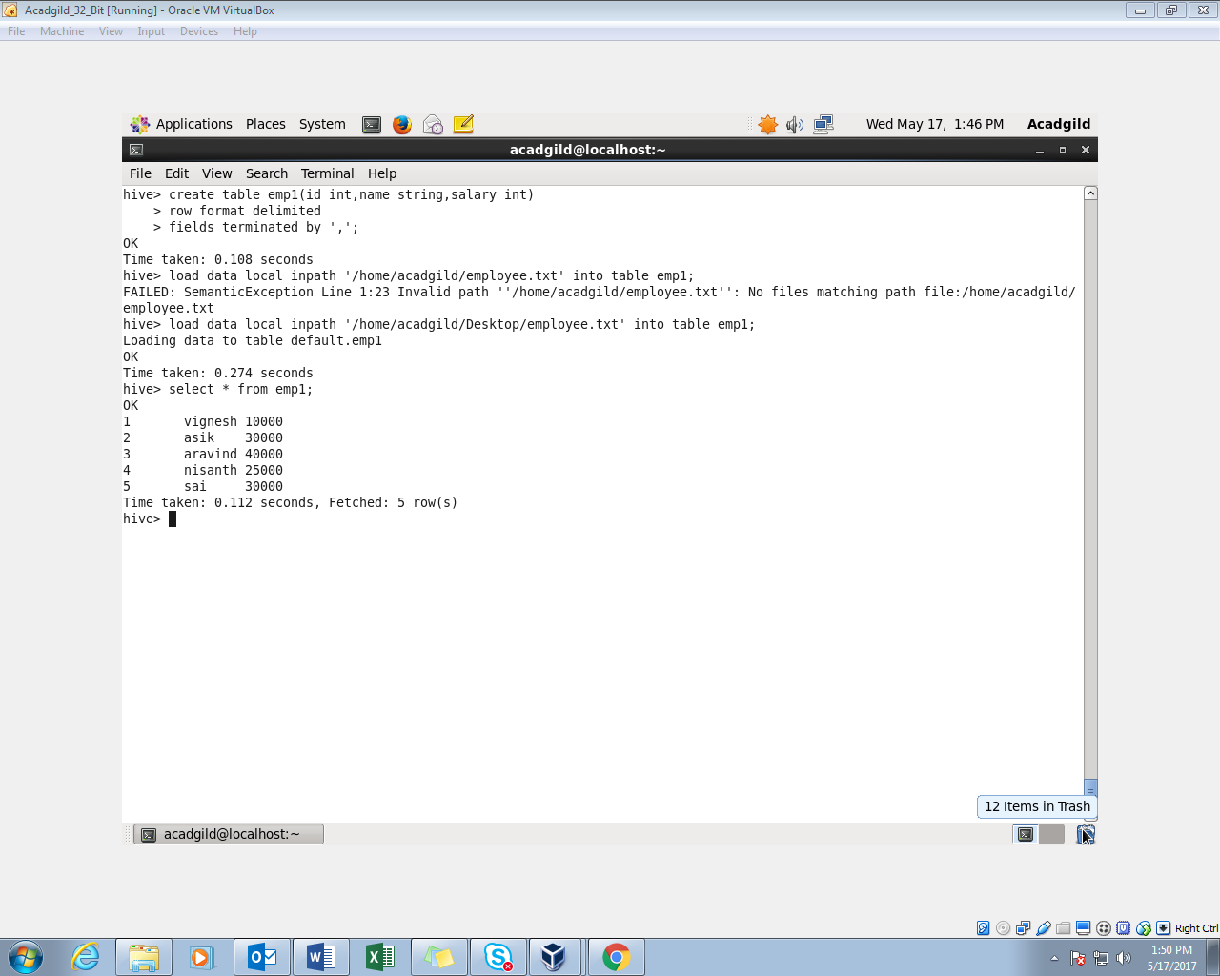

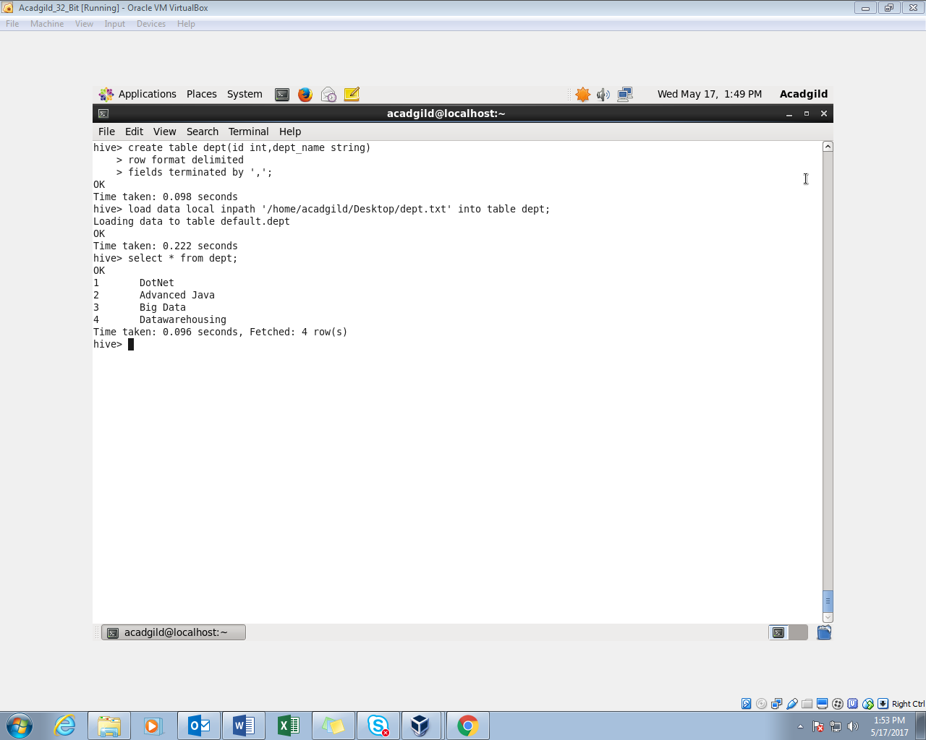

1. Join table ordering (Largest table last) : In our case the large table is employee table so it is joined as a last table.

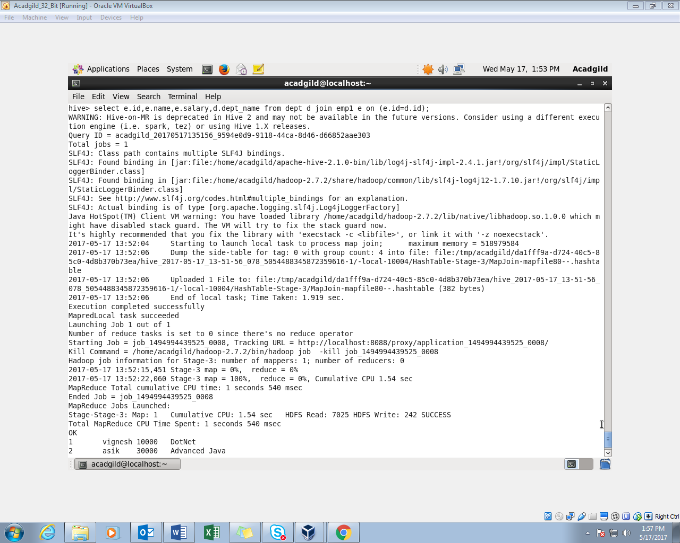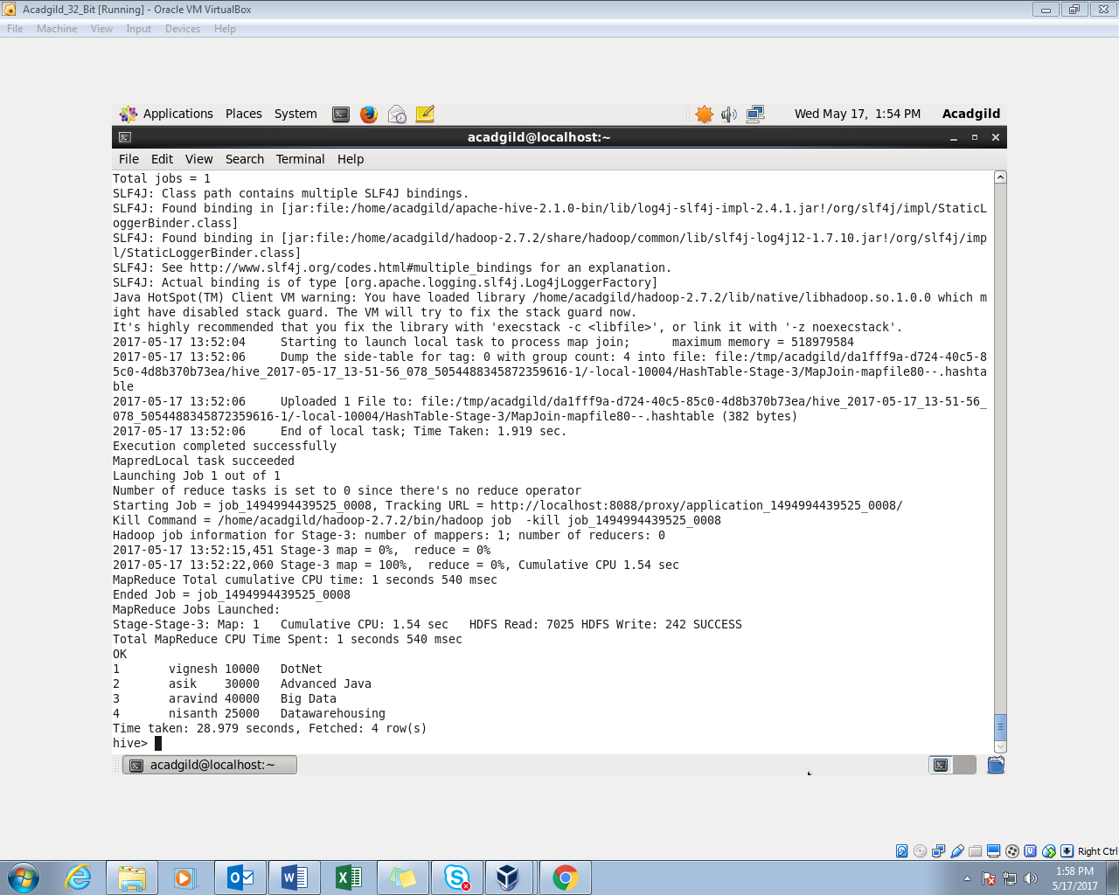

Instead we can also explicitly stream the table using stream table command

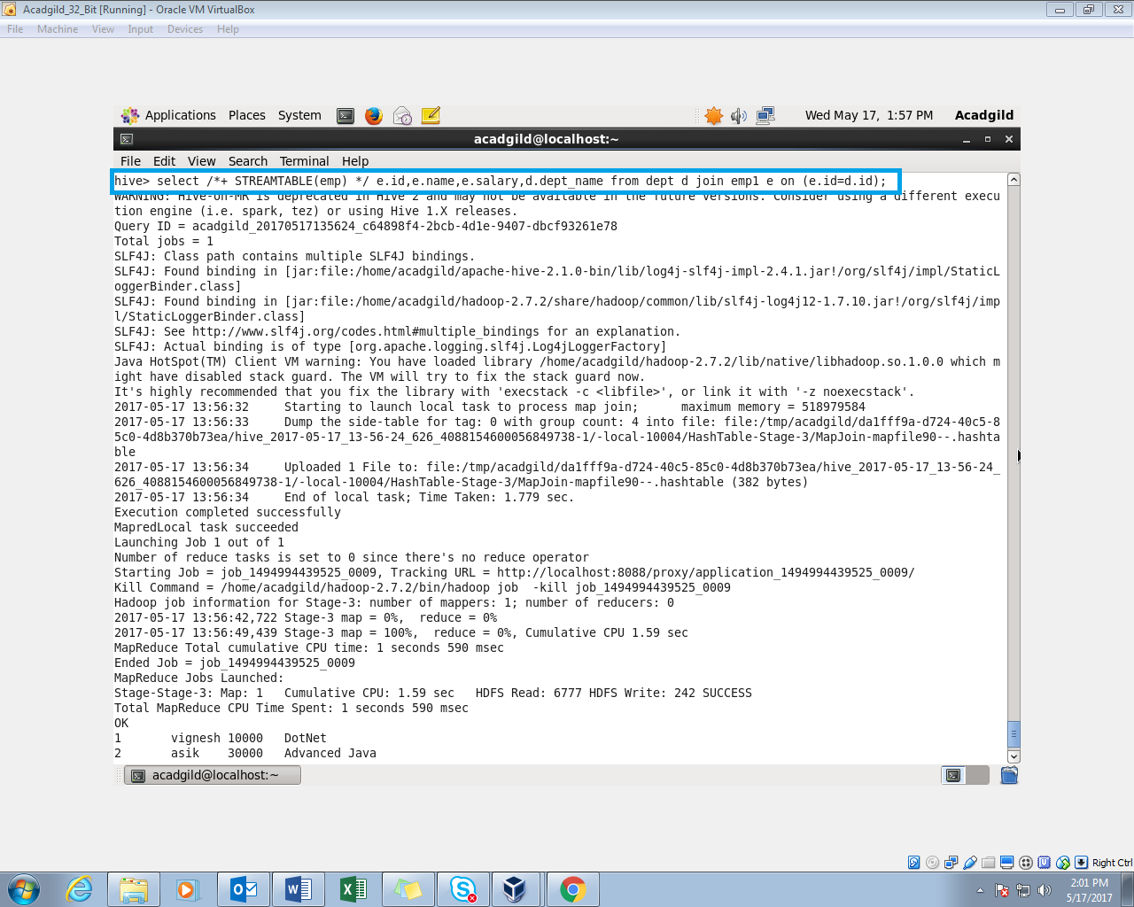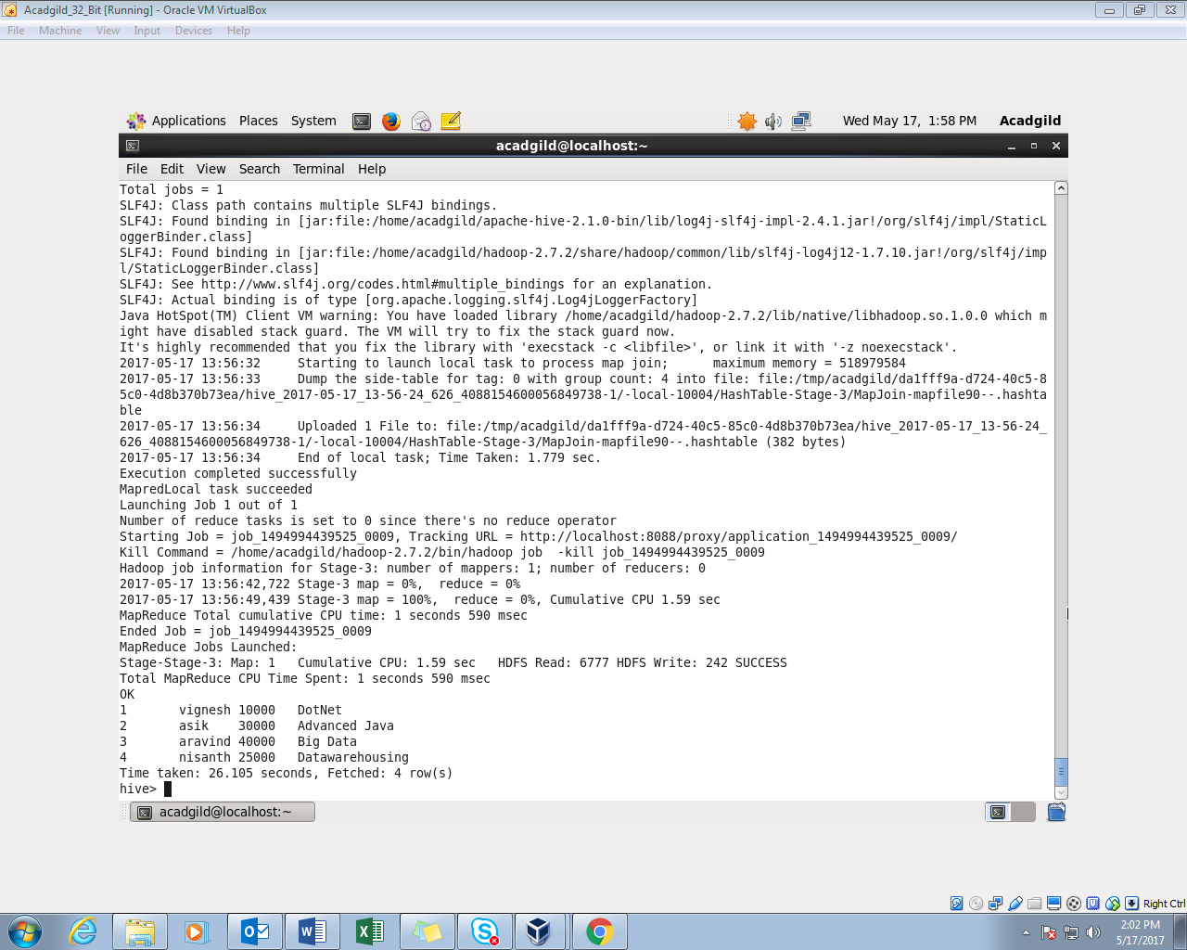

1. Map Side Join:

Set hive.auto.convert=true and Set hive.nonconditional.task=true;

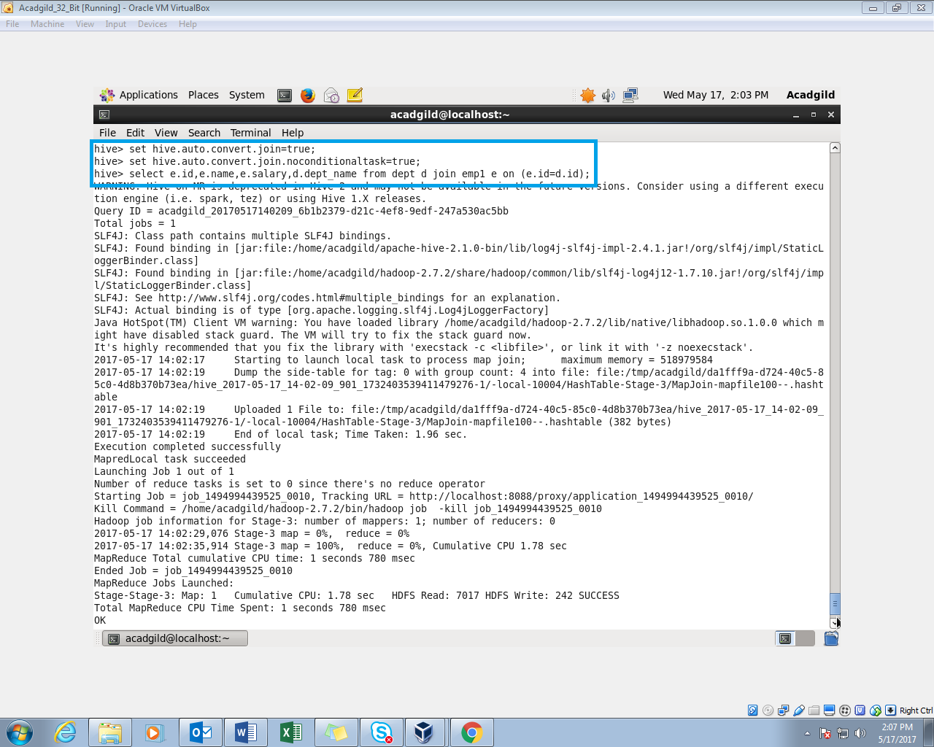

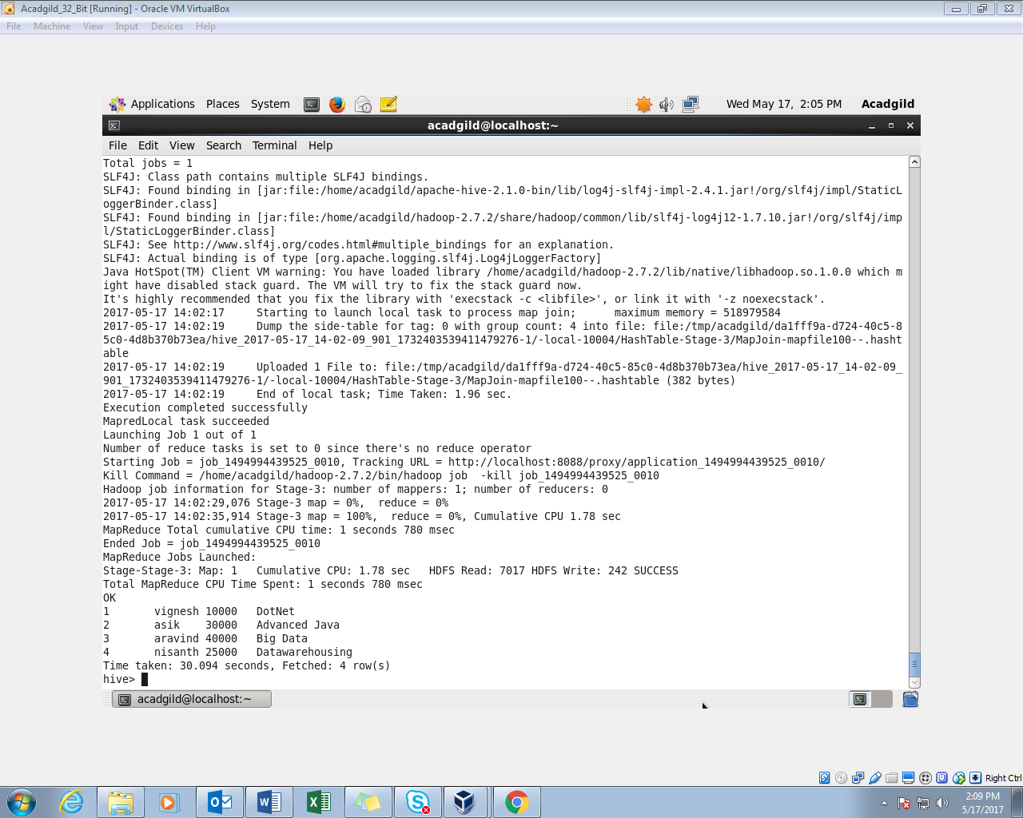

1. Bucket Map Join: Creating the bucket table for both the employee and department.

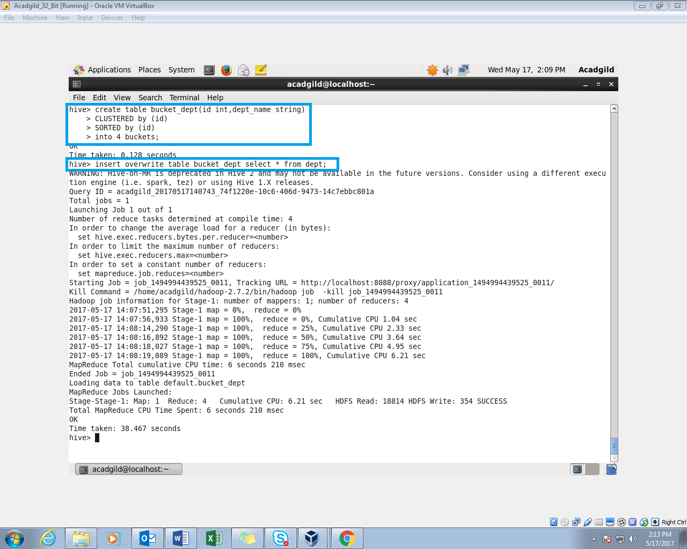

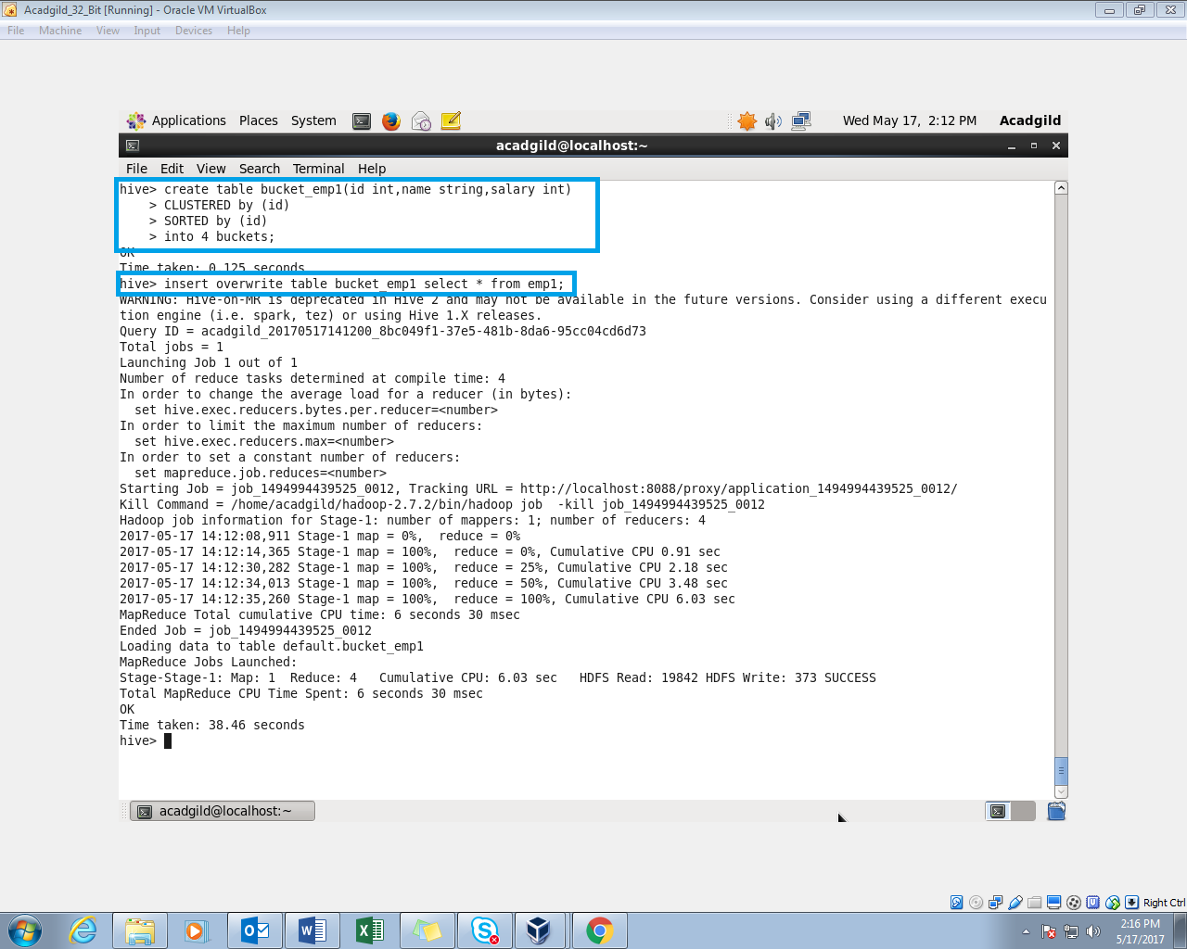

Then in order to perform bucket map join set hive.optimize.bucketmapjoin=true and perform map join

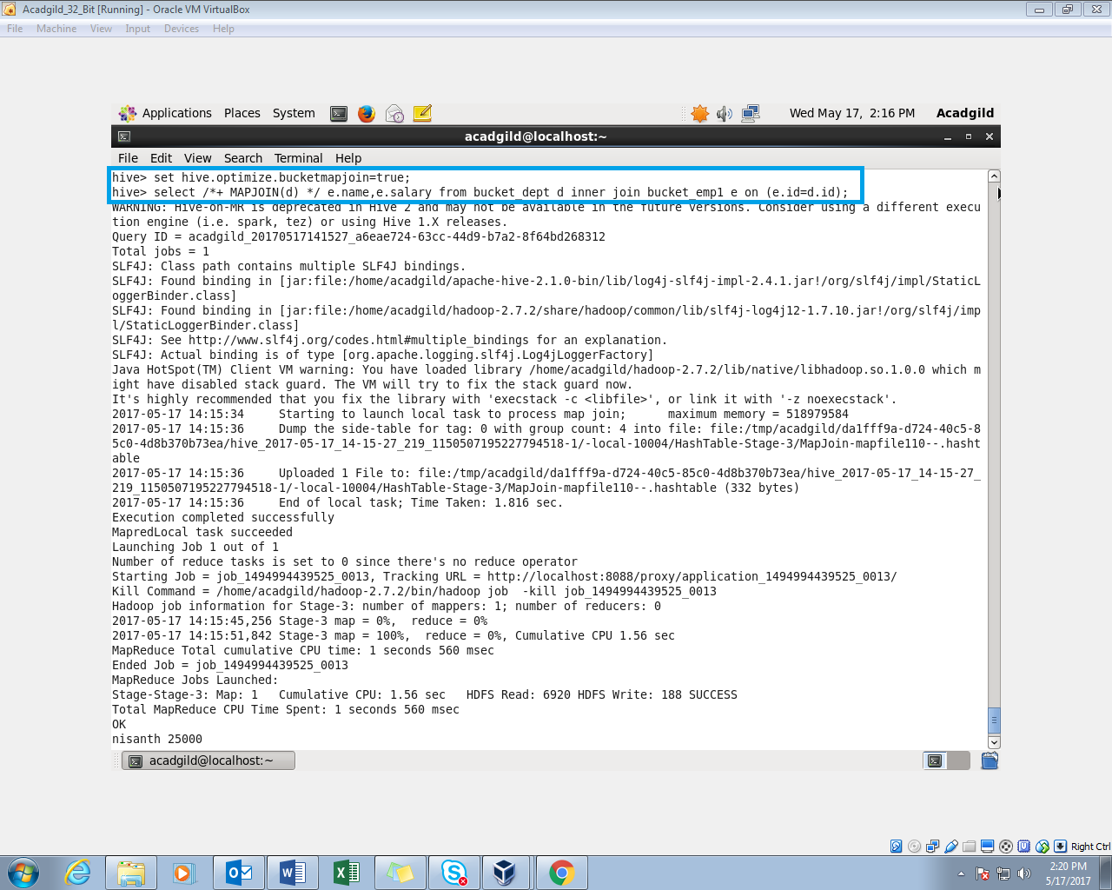

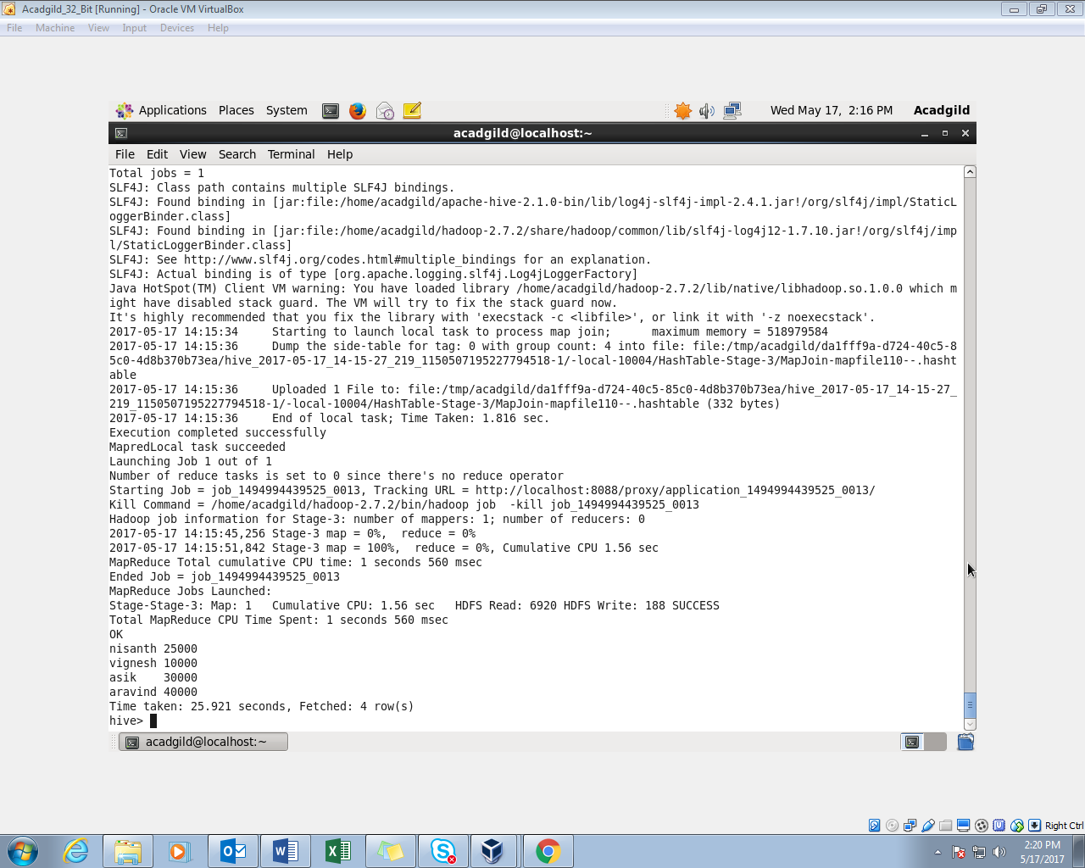

1. Sort-Merge-Bucket-Map Join

